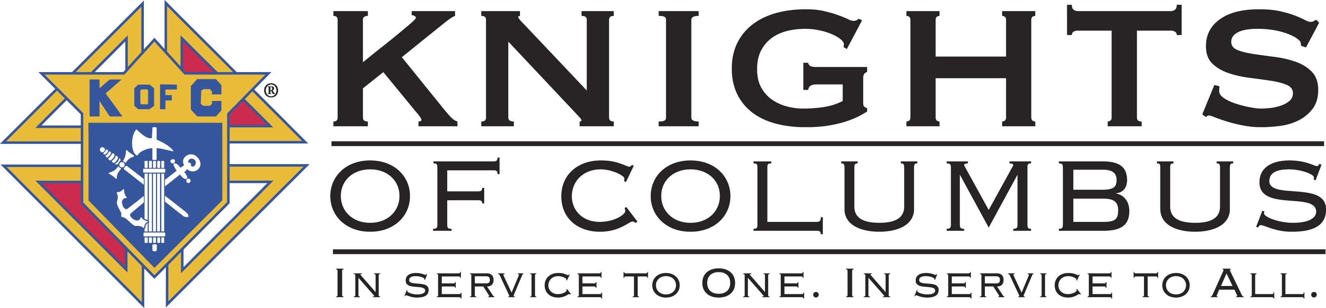
OKLAHOMA KNIGHTS OF COLUMBUS
2012 STATE CONVENTION
April 27th, 28th, 29th, 2012
Hosted by: Norman Council #8523
Embassy Suites Hotel & Conference Center
Norman, Oklahoma

Knights of Columbus Council # 8523 of St. Thomas More University Parish is proud to host the 107th Knights of Columbus Oklahoma State Convention to be held on the weekend of April 27th, 28th, & 29th, 2012. This year’s convention will be held at the luxurious Embassy Suites Hotel & Conference Center located at 2501 Conference Center Drive in the new University Park Development.

The Embassy Suites has set aside a block of rooms for the convention at a special rate of $133.58 tax included. Reservations should be made as early as possible as a deadline of April 6th has been set to receive this special rate. Reservations need to be made directly with the Embassy Suites at (405) 364-8040 and indicate the Knights of Columbus Convention to receive the discounted rate. Remember the deadline for hotel reservations is April 6, 2012.

On Friday evening, Knights of Columbus Council #8523 is conducting a Casino Night for the evening’s entertainment. A variety of casino type games will be utilized for this event; some being the usual type games of blackjack, roulette, craps and poker tables along with some unique games for all levels to enjoy. Light hors d’oeuvres will be served and the hotel will provide a cash bar.

The Memorial Mass will be held on Saturday, April 28th at 5:00 pm @ St. Marks located at 3939 W. Tecumseh Road. The church is a short drive from the hotel and a bus is being made available to assist with the transportation.

A special committee worked diligently to provide a number of special activities for the ladies attending this year’s convention. A detail flyer is included with the convention packet.

The advertising information for the Convention Program is included with the convention packet and we invite and encourage all councils to support the host council by purchasing advertisement for their council or businesses in support of the Knights of Columbus.

All registration packets along with all the associated fees are to be returned to the Worthy State Secretary Ron Schwarz who will obtain all the delegate registrations then forward all the necessary materials and fees to our Council for processing.

We are looking forward to serving as the host for the 107th Oklahoma Knights of Columbus State Convention. We are working hard to ensure that everybody has a positive experience and we are thankful for this opportunity. See you in April!

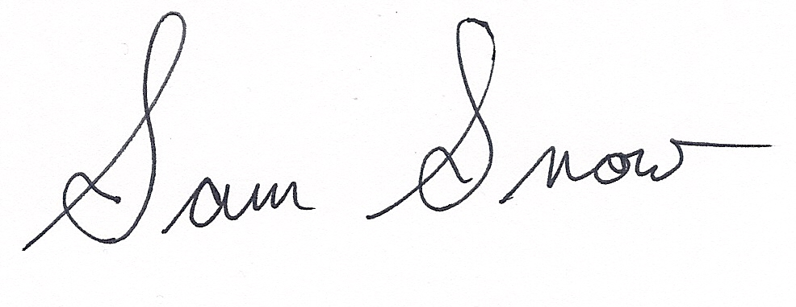
Fraternally yours,

Sam Snow, Grand Knight
Norman Council 8523

